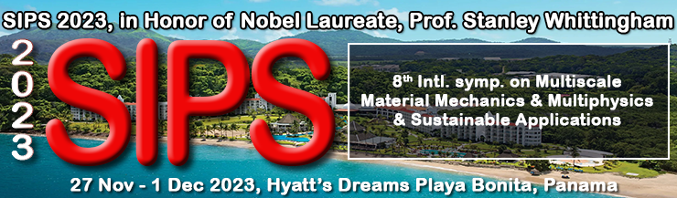

Dear colleague,

On behalf of Prof. Elias Aifantis (Aristotle U. of Thessaloniki, Greece), Dr. Raj Das (RMIT U., Australia) and Prof. Patrizia Trovalusci (U. di Roma La Sapienza, Italy), co- chairs of 8th International Symposium on Multiscale and Multiphysics Modelling for 'Complex' Materials, in my capacity as President of SIPS 2023, I am personally inviting you to participate as an author/speaker at this major symposium. This symposium will cover but not limited to composites, complex material behavior, non-standard/non-local continuous formulation, computational methods for non-standard continua etc.. These and many others are among the topics of the symposium.

This symposium will be held as part of SIPS 2023, an annual multidisciplinary summit, organized by the not-for-profit corporation FLOGEN Stars Outreach (www.flogen.org), which is dedicated to achieving sustainability through science and technology applied in various fields. It incorporates summit plenary lectures from well-known speakers that address the link between various domains in the pursuit of sustainable development, as well as specific scientific symposia featuring specialized presentations in a specific domain, with the same goals in mind. The symposium and overall summit will be held in Panama from November 27th – December 1st 2023 in Hyatt’s Dreams Playa Bonita.

Please submit the abstract using this link: https://www.flogen.org/sips2023//abstract_submission.php?p=35#top4

Other additional information about this symposium, SIPS 2023 can be found in the official invitation: https://www.flogen.org/sips2023//pdf/Modelling_General_Author_Invitation.pdf

The papers will be double peer reviewed and published in the official Publication entitled: “8th International Symposium on Multiscale and Multiphysics Modelling for 'Complex' Materials” containing ISBN and ISSN numbers and indexed by Google Scholar joining the existing 3000 SIPS articles (https://bit.ly/3qRrdGt). Furthermore, many papers upon significant will be subsequently published as part of special volume of relevant Journal dedicated to this symposium.

As an invitee, if you prefer to deliver a presentation with a wider scope for one of the listed topics, or on a new specialized topic of your choice, we would be pleased to take it into consideration for a possible nomination as an Invited or Keynote Lecture.

In this case, please send us an email at the same address, which should indicate your interest and include a draft abstract.

Pertinent information from our website:

SIPS 2022 Video Synopsis of 23 minutes: https://www.youtube.com/watch?v=kUyfcO6QbKY
Some videos from previous SIPS Symposiums are presented here: https://flogen.org/?p=71
SIPS impressions over the years: https://flogen.org/?p=110
Video impression over the years: https://flogen.org/?p=79
Highlights of FLOGEN and SIPS activities https://www.flogen.org/?p=105
Hall of Fame: https://www.flogen.org/?p=92

*An overview of previous SIPS held at various locations all over the world (USA, Mexico, Turkey, China, Brazil, Cyprus, Thailand) can be found here: https://flogen.org/?p=32&an=2002

The symposium is the optimal conference to present your most recent work, listen to the latest achievements of your colleagues, and interact with well-known experts from diverse fields of industry, academia, and politics. We hope your participation will enable your organization to improve efficacy and implement the best sustainable research and industrial practices.

It would be a great pleasure to have you join us. We are looking forward to hearing from you.

Dr. Florian Kongoli
President SIPS 2023
Organizing Committee

FLOGEN Stars OUTREACH
(Not-for-profit corporation)
Giving STAR Power to Scientists, Technologists and Engineers and to People Who Help Them 1255 Laird Blvd., Ste. 388-1, Mont-Royal, QC, Canada, H3P2T1
Toll-Free (N. America): +1-877-2-FLOGEN Tel: +1-514 807 8542 Fax: +1-514-344-0361;
Web site: www.flogen.org E-mail: secretary@flogen.org

